Discrete Simulation of 3DOF Soft Haptic Device – Midterm Report
Luke Sage
Background:
Soft robotic actuators in haptic devices allow for soft, safe, and comfortable touch. Strategies are wide ranging from knit sleeves with inflatable pouches [1] to multi degree-of-freedom wrist watch style mounted devices [2]. With robust 3D-printing methods, researchers have developed low-cost haptic devices [3] and used them to convey complex patterns and guide users along paths via haptic feedback [4]. Among existing devices mounted on the forearm, there is usually a tradeoff between multiple actuation modes (shear, normal and vibration) and number of actuation points. A device that has both a large number of actuation points, (nodes) as well as the ability to apply multiple kinds of force at each node would be able to provide a greater number of potential haptic outputs, increasing the density of information able to be communicated. For example, shear force could provide real-time navigation information to a user, allowing them to get from point A to point B without a visual or auditory interface.
A robust simulation model of such a device will be important in its design and control, allowing more precise application of force. To this end, a discrete soft structure model will be created to accurately predict the deformation of the haptic device.
A design for a compact, 3 degree of freedom soft haptic node is proposed using bowden cable actuation for position control. Bowden cables are common in soft robotics, allowing rigid motors and other actuators to be tethered to the soft elements of a robot [5]. The design will consist of a central pillar of elastomeric material, which is constrained by pulling force from 3 bowden cables. A discrete simulation of this actuator provides knowldege advantages: Firstly, knowledge of the expansion of the bladder as it inflates will allow much more precise design iteration.
We would like to understand the position of the top of the bladder as a function of the force provided by the pneumatic muscles, as well as the bladder’s internal pressure. The physical haptic node will be constructed of 3D printed TPU material.

Methods
We propose a simulation model to examine the response of the haptic node to a pressure load as well as a lateral tension force from the pneumatic muscle. The overall structure we are modelling will have three possible degrees of freedom: two in translation, one in normal. First, a two-dimensional “beam” model was created to represent the main pillar structure. The primary structure of interest originally is shown in figure 1.

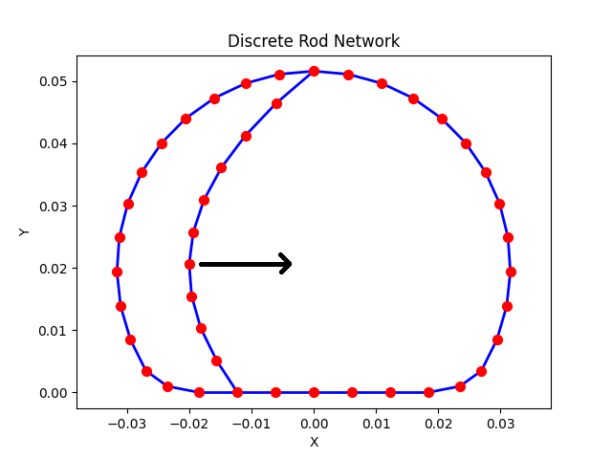
Figure 1: The discrete rod network representing a prototype haptic node

For this haptic node, external tension forces tension forces were applied to represent the bowden cable inputs. The goal of this particular sample node geometry was to evaluate the effectiveness of a “buckling” beam in the center, that when pulled, would change the y position of the top of the dome. The direction and position of the applied force is shown by the black arrow on Fig. 1. The load is applied with a sigmoid function as shown in Figure 2. The load is scaled such that it is sufficient to deform the geometry of the node.

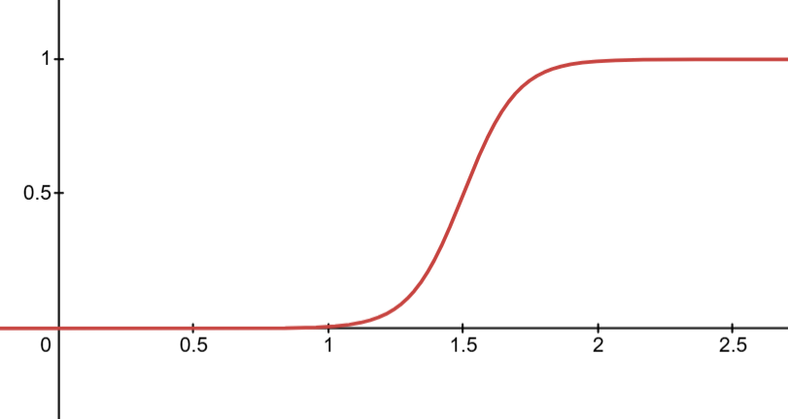
Figure 2: Sigmoid function describing load application over time

Preliminary Results and Analysis
The discrete beam network model has been evaluated for the structure shown in Fig. 1. Figure 3 shows the position of the node before the load is applied.

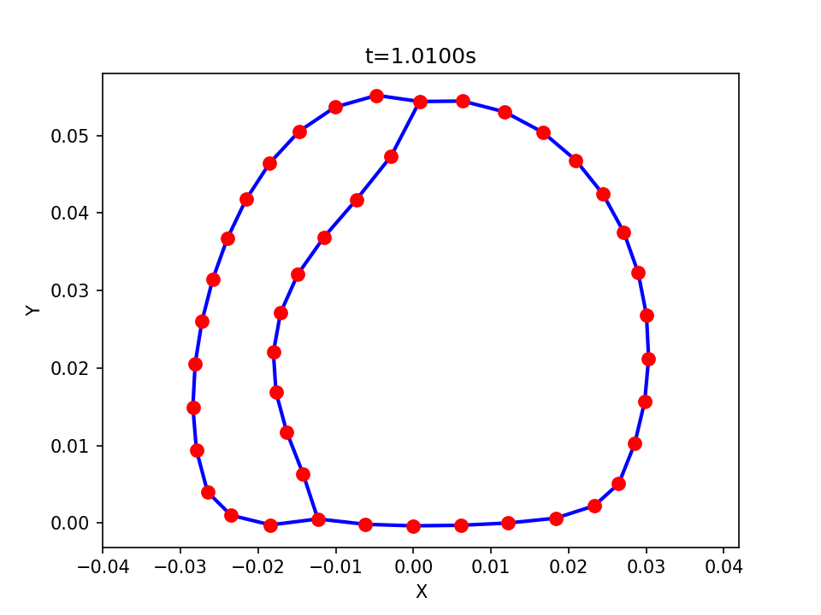
Figure 3: Deformed haptic node at 1.01 seconds

Figure 4. shows the position of the node after the load has been applied, and a steady state has been reached.
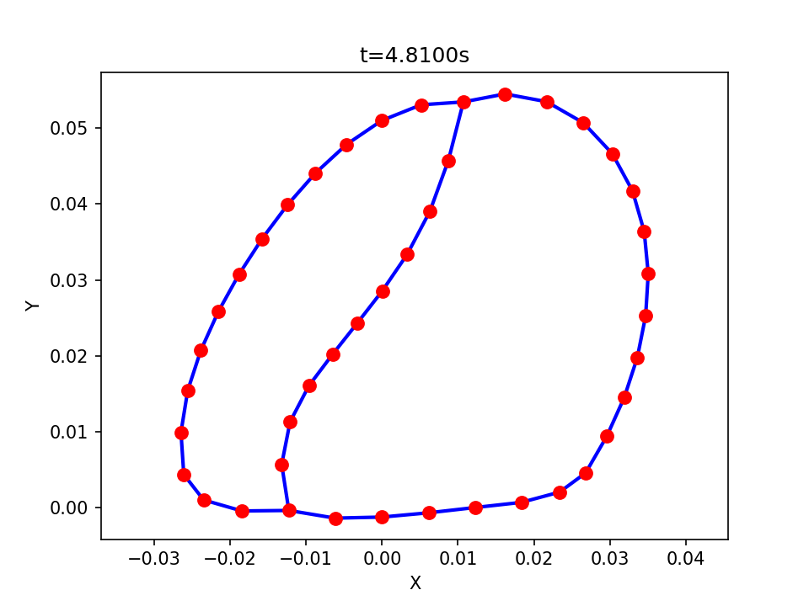
Figure 4. Deformed haptic node post load application

The effect of the buckling beam can be seen to have little effect on the Y position of the top of the haptic node. Rather than buckle and push the node upwards, the center beam bends to the right with the rest of the node. The Y position of the tip of the haptic node is plotted over time in Figure 5.
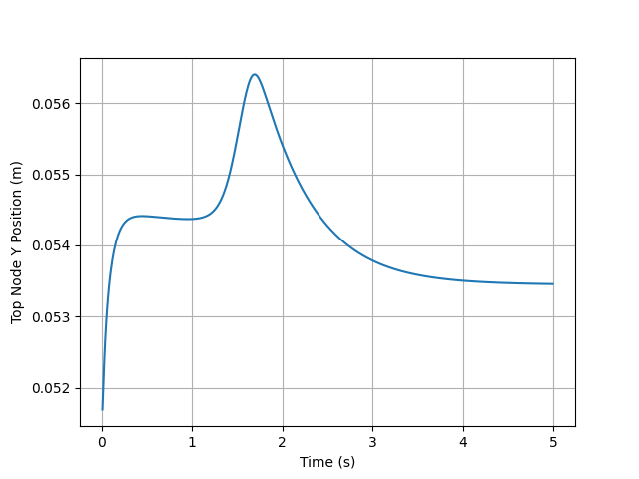
Figure 5: Y position of the tip of the haptic node

It is clear that the application of the load does not have a significant effect on the position of the node. Although this geometry was intended to be a test case for the node, the lack of Y movement in the top of the node indicates a geometry modification is necessary.

Future Work
The remainder of the work that will be done for the scope of this project will consist of reworking the simulation model to function in 3 dimensions. Since the intent of this project is to provide a foundation for informing the design of the haptic nodes, the project will focus mostly on developing an accurate and useful model of TPU material in rod networks. More background work will be necessary to determine whether twisting wil be a required mechanism to include, since the models will have little or no moments applied to the structure.
Simple TPU components will also be printed to use as validation for the models. First, they will be compared to the 2D beam model, then the 3D rod network model to ensure parity between the two and similarity to the real TPU material.
Additionally, a slight contracting effect is visible at the beginning of the simulation model. This effect is visible when comparing the initial positions of the node in Figure 1. With the unloaded steady state position of the node in Figure 2. Future work will be directed at understanding this slight contraction.

Conclusion
This project will provide the foundation for iteration on the haptic node. The ultimate goal is to create a robust simulation model which will be able to replicate the deformation of a node based on control forces. With a complete model of the behavior of a node, it will be possible to accurately position the node and provide a wide range of haptic touch patterns to a user, allowing a greater degree of human-computer interaction.

Bibliography
- C. du Pasquier et al., “Haptiknit: Distributed stiffness knitting for wearable haptics,” Science Robotics, vol. 9, no. 97, Dec. 2024, doi: https://doi.org/10.1126/scirobotics.ado3887.

- K. T. Yoshida, C. M. Nunez, S. R. Williams, A. M. Okamura and M. Luo, "3-DoF Wearable, Pneumatic Haptic Device to Deliver Normal, Shear, Vibration, and Torsion Feedback," 2019 IEEE World Haptics Conference (WHC), Tokyo, Japan, 2019, pp. 97-102, doi: 10.1109/WHC.2019.8816084.

- R. Mutlu, D. Singh, C. Tawk, and E. Sariyildiz, “A 3D-Printed Soft Haptic Device with Built-in Force Sensing Delivering Bio-Mimicked Feedback,” Biomimetics (Basel), vol. 8, no. 1, art. 127, 22 Mar. 2023, doi: 10.3390/biomimetics8010127.

- E. H. Skorina, M. Luo, and Ç. D. Onal, “A Soft Robotic Wearable Wrist Device for Kinesthetic Haptic Feedback,” Frontiers in Robotics and AI, vol. 5, art. 83, 23 July 2018, doi: 10.3389/frobt.2018.00083.

- Q. Guan, F. Stella, C. Della Santina, J. Leng, and J. Hughes, “Trimmed helicoids: An architectured soft structure yielding soft robots with high precision, large workspace, and compliant interactions,” npj Robotics, vol. 1, no. 1, Oct. 2023. doi:10.1038/s44182-023-00004-7

